Brick by Brick Success in Business and Life – Paul Bassi CBE Book Review

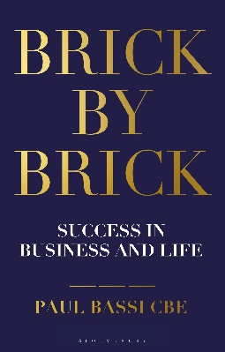
This book was very interesting, it is all about being successful in life and realising that you are able without knowing how close you really are to success. Success is a simple thing that most people believe to be something mysterious and complicated - the reality, according to Paul Bassi, is something completely different. In the vast majority of cases, the people at the top have got there by following disciplines that open to everyone. The truth about success is that it's closer than you might think but harder work than you expect. Success in business and life is a very inspirational and rewarding book, which outlines how everybody can be successful they are all closer than they think, but do not know it. Success is a simple thing that most people believe to be something mysterious and complicated - the reality, according to Paul Bassi, is something completely different.
Paul Bassi explains that anyone can be successful in life - by your own definition, which is the only one that really matters - if you set yourself a central ambition and follow some fundamental principles about how it can be achieved.
The book draws upon stories from his youth, early career, family life and his current position as one of the Midlands' most prominent property investors, Paul Bassi shows how you can plan your own journey to success. Bassi quotes ‘It won't be easy; it won't happen overnight; and it won't come without making sacrifices. But if you want it badly enough and are prepared to be disciplined and relentless in your approach, it is all perfectly possible.’ This book will show you exactly what it takes and how close and how hard you need to work to achieve the best that you can. This is a very inspiring book to read and with the motivational quotes and messages you can put this practice into your own life plan.

By Holly

