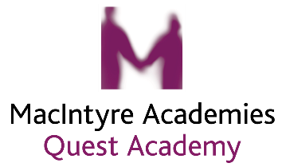

Quest Academy Recovery Curriculum 2020 Parent/Carer Conversations
These questions are to support the 5 levers of our Recovery Curriculum
Childs Name: Class:
What have been the challenges of returning to school?
How does your child feel now?
What are your child’s worries and fears?
What help would they like with their learning?
How can we further support them at school?
How can we support you as parents/carers?
Do you have any questions?
Is there anything else that you feel we should know?

Please return to the Quest office at: quest.office@macintyreacademies.org

Thank you for your continued support.

