Modern Families: Parents and Children in New Family Forms
Susan Golombok

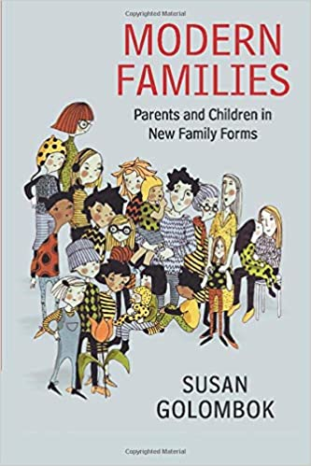
Why is this book relevant to Quest?

‘Modern Families’ argues that children raised within new family structures do not typically show psychological adjustment problems. However, certain aspects of these family types may still present difficulties for children. For instance, some children with same-sex parents experience stigma at school. Such problems are associated with poor communication (both inside and outside the family) and discrimination within society.

As a result, the onus is placed on us, as educators, to teach our learners about new family forms. Such policies are already being enforced nationally – e.g. Stonewall UK (2010) produced guides for schools to help counter homophobia and increase the awareness of the needs of children with same-sex parents. Improving the understanding and tolerance of new family forms, will not only protect the well-being of any learners being raised in these family structures, but help all learners participate in society more harmoniously.

Modern Families discusses a growing body of research on parenting and child development in new family forms.

‘New families’ are defined as family structures that were hidden from society until the late 1900’s, and that represent a more fundamental shift away from the traditional nuclear family than non-traditional families do (those formed by relationship breakdowns and reformation). Such new family forms include lesbian mother families, gay father families, families headed by single mothers by choice, and families created by assisted reproductive technologies (e.g. surrogacy, IVF).

New families are the subject of enormous controversy, as opponents claim they inhibit children’s socio-emotional development. Much of these claims are founded in myths; the empirical research contained within ‘Modern Families’ aims to challenge such false assumptions.

‘Modern Families’ argues that family structure- including the number, gender, sexual orientation, genetic relatedness of parents and method of conception- does not play a fundamental role in children’s psychological adjustment. Rather, the quality of familial relationships and social attitudes towards the family are more predictive of a child’s socio-emotional development.

